**Booking Page Form Validation Process**

Firstly I added an event listener to ensure the form loads fully before any javascript runs. I also added a second event listener that prevents the form submitting straight away (it prevents the default action).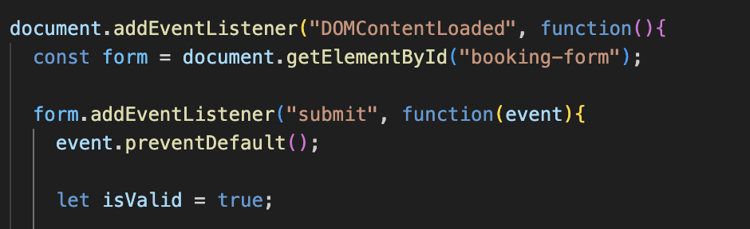

I then added .getElementById to access each input field so as it can be validated later on.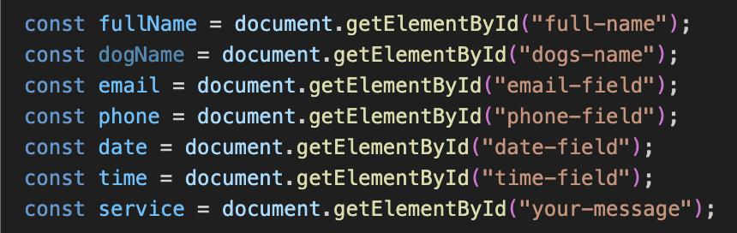

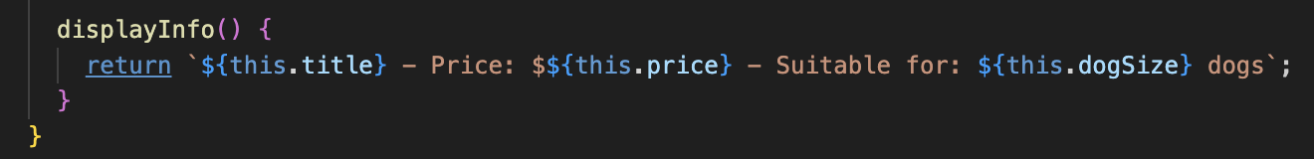

The below code was then used to ensure that any existing error messages were cleared.



I then added the showError function, which displays an error message based on arguments that will be later stated. It creates a new <span> element to display the error message and uses insertAdjacentElement to place the error message under the input field.

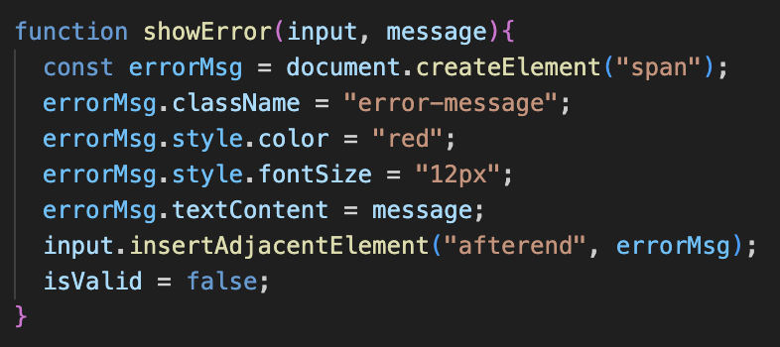

The below code validates the full name field. Trim() removes any unnecessary spaces while showError is called if the field is empty.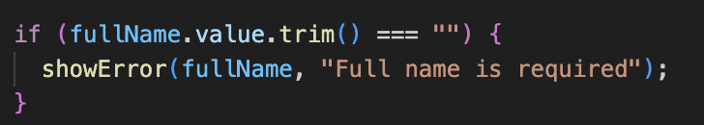

This code validates the email address. The regex (regular expression) makes sure that the email has a valid format such as "[name@yahoo.com](mailto:name@yahoo.com)". It then checks if the input matches the email format. If the email does not match the expected format, an error message displays.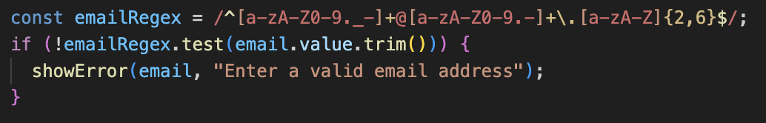

I then added the code to validate the phone number field. Similar to the email validation, it uses regular expression to check if the phone number is valid. In this case, the phone number cannot be less than 10 digits long. If this is the case, an error message is displayed.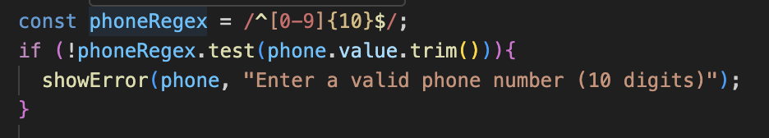

The below code was then added to validate remaining fields such as date, time and service fields.

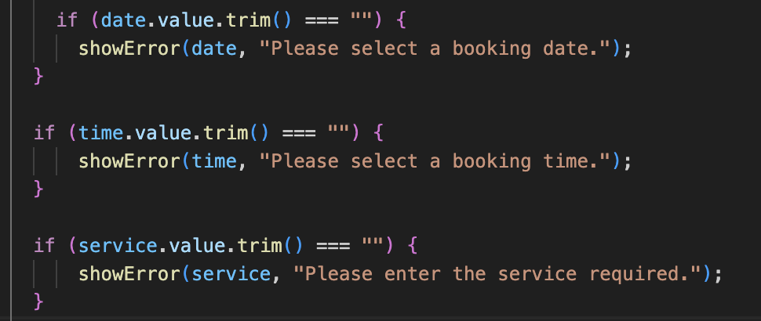

The final line of code ensures all fields are valid before allowing the form to be submitted.